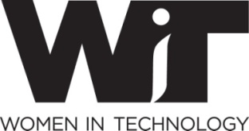
Programs Committee
Our Mission—
Provide high-value networking and educational programs for WIT members
-
The Programs Committee develops, plans, organizes, and executes WIT ’s flagship monthly event – the WIT.Connect-- generally held on the 3rd Thursday of the month.
Do you want to…
- Meet new people?
- Explore ideas at the leading edge of technology issues?
- Stretch your Project and Event management skills?
- Delve into marketing and social media?
- Build relationships and have some fun?
Then…We invite you to volunteer with us!
Programs Committee Volunteer Opportunities
Volunteer opportunities capitalize on the following essential business skills:
Project management -- Relationship building -- Planning, organizing, executing
Administration & logistics -- Marketing and business development – Personal and team leadership
Some of the ways you can get involved:
- Do you have an interest in Cyber, Leadership, Cloud, Environmental Sustainability, Women’s Issues, Big Data…?
  - Lead or be part of an event team
  - The monthly WIT.Connect highlights a wide range of top technology issues. Working with us you’ll explore what’s on the leading edge of a favorite topic.
- Do you want to stretch your skills in a particular area--marketing, social media, or project planning? You can choose to help each event team with that functional area.
Committee Meetings:
- Twice-monthly planning conference calls & an in-person social meeting every quarter.
- We also know you don’t volunteer just to work…you volunteer to build deeper relationships. We put emphasis on socializing, recognition, and fun.
Contact Irene Lane (Chair), irene@geenloons.com
OR Heather Diehl (Vice-Chair), heather.diehl@gmail.com to get involved.

