Women In Technology
Presents
WIT.Connect: Artificial Intelligence – Its Applications and Impact

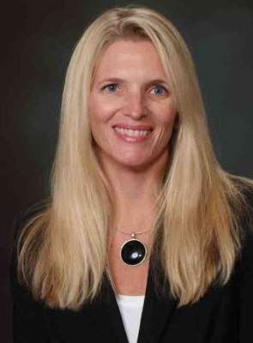
Nicole Bradley, Senior Core Watson Platform
IBM

Nicole is a native Virginian who has been in Technology since 1993. She moved from the hardware and storage space to software and specifically Analytics, Advanced and Business Intelligence in 2010. In 2015, she realized her dream and took a role at IBM Watson. Nicole worked in Retail Consulting prior to focusing on the Financial Services space. She joined the IBM Watson team in June of 2015, celebrating an 18-month journey from the formalization of Watson at IBM. Prior even to the Announcement of IBM Watson as a distinct business unit in IBM, she was engaged in one of the first commercialization uses of Watson in the Financial Services arena as the lead Advanced Analytics Specialist on the project. She is a mentor for IBM’s greatest freshest minds and enjoys working with the Analytics students at Fordham University also in a mentor capacity. lauren.toth@ngc.com

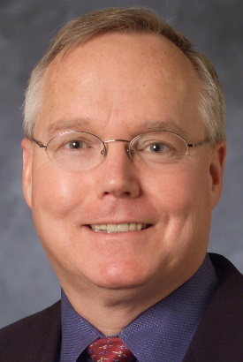
Chuck Howell, Chief Engineer for Intelligence Programs and Integration,
MITRE Corporation

Chuck Howell is the Chief Engineer for Intelligence Programs and Integration at the MITRE Corporation. He contributes to oversight of technical activities across MITRE’s Intelligence programs, including participating in the development and integration of MITRE’s research program, direct technical support to projects, and review of technical aspects of Intelligence Community programs.

He was the Chair of a DARPA panel refining a research agenda for Building Trustworthy Systems, Chair of a three-FFRDC study for DUSD (S&T) to develop a roadmap for S&T in software engineering, the MITRE lead for a team (MITRE, Aerospace, Johns Hopkins APL) that developed a recommended set of Mission Assurance Program guidelines for the Missile Defense Agency, and has been a Principal Investigator on multiple MITRE research programs addressing various aspects of software assurance, safety cases, autonomy, and error handling. He was co-chair for 2015 and 2016 Association for the Advancement of Artificial Intelligence workshops on “Cognitive Assistance in Government and Public Sector Applications.” He previously worked at Sun Microsystems, Mitretek/Noblis, Reliable Software Technologies, Verdix, and Computer Sciences Corporation way back in the 20th Century. Howell@mitre.org

Lauren Toth, PhD., INCOSE ASEP Systems Engineer
Northrop Grumman Corporation

Dr. Lauren Toth received a Bachelor’s degree in Chemical Engineering and Biology from MIT and a Doctorate in Biomedical Engineering from Duke University. Dr. Toth’s research at Duke centered on gene therapy, gene editing, and regenerative medicine; and it involved the design and development of optogenetic tools that could control cellular gene expression and behavior in response to blue light. Using advanced genomic technologies, including CRISPR/Cas9 and TALE transcription factors, she engineered unique systems for organized muscle growth and blood vessel formation.

Dr. Toth joined Northrop Grumman as part of the Future Technical Leader Rotation Program in June 2015. As part of the program, she will complete three one-year rotations. Her first rotation was as a subject matter expert in bioinformatics and genetic engineering in the Personalized Healthcare group in McLean, VA. She is currently in her second rotation in Brooklyn, NY, where she supports Northrop Grumman’s New York City Wireless Network (NYCWiN) program, which provides a private, secure wireless network for first responders and state agencies across all five boroughs of New York City. She also serves as the principal investigator of a Secure Mobile Communications R&D program, which is developing a secure mobile device for the storage and transmission of classified voice and data.

David C. Woessner, General Manager
Local Motors, Inc.

David C. Woessner serves as the first General Manager of Local Motors, Inc. He is responsible for operations of the educational, sales, and demonstration facility in National Harbor, MD. His primary focus is working with local stakeholders to develop and build a full micro-factory in the Washington DC region to produce locally relevant vehicles. Additionally, he is working to establish Local Motors’ presence and an associated micro-factory in Detroit while helping to usher in a new industrial age of vehicle innovation and technology. Prior to joining LM, David served as Senior Advisor for Jobs & The Economy in the City of Detroit, leading the development of strategies and policies to create a business environment that would enable corporate entities to successfully grow their organizations. He also served as a managing principal at P3 Group’s Strategy Consulting practice where he lead business development, marketing and sales across the Americas. Prior to P3, David spent four years at Deloitte Consulting in the Strategy and Operations practice working on Global M&A, primarily in automotive and technology industries.

David is an expert in topics of globalization, localization, and emerging technologies and has written articles and white papers on mobility, connectivity and automotive technology hubs. He has over 15 years of executive leadership, strategy, business development, sales and relationship management experience. He has worked with Fortune 500 companies, startups, private equity firms, venture capitalist, academia and government entities. @global_wooz | @localmotors | facebook.com/localmotors

